LifeCycle Criteria

Voyager Employee Recall Leave of Absence

Lifecycle Event Details
Attribute | Value
Lifecycle Event Name | Voyager Employee Recall Leave of Absence
Lifecycle Event Type | Rule
Workflow Name | Voyager Place and Recall Leave Of Absence Workflow

Event Rule Logic
The script returns true only when a user's status transitions back to an active state, the specific "Return from LOA" action code is used, and the change is currently effective.
- Assignment Status Match: The assignmentStatusTypeCode must be exactly "Active - Payroll Eligible".
- Action Code Match: The newActionCode must be exactly "ASC_RETURN_LOA".
- Change Required: The new action code must be different from the previous action code (case-insensitive).
- Effective Check: It verifies that the effectiveDate (return date) is today or in the past.

Additional Event Criteria
The lifecycle event will execute only when the following conditions are satisfied:
- Worker Validation
  - WorkerType must be one of the following values:
    - E (Employee)

Flow Chart
Voyager Place and Recall Leave Of Absence Workflow
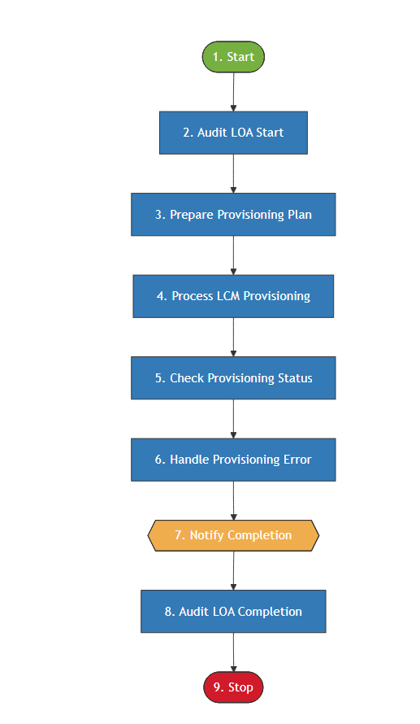

Step Summary

Voyager Suspension Workflow – Step Summary
Step No. | Workflow Step | Description
1 | Start | Initiates the workflow when the Voyager Employee Pre-Hire lifecycle event is triggered.
2 | Audit LOA Start | Records an audit event indicating the initiation of the Employee LOA Event
3 | Prepare Provisioning Plan | Prepares a provisioning plan to disable Identity application accounts except(AD,EPM,UKG.DUO, GSuite, ServiceNow and PA).
4 | Process LCM Provisioning | Executes the provisioning plan through the LCM Provisioning Workflow and creates a ServiceNow incident if errors or warnings occur.
5 | Check Provisioning Status | Reviews the provisioning results and stores any application-specific errors or warnings.
6 | Handle Provisioning Error | Errors are logged
7 | Notify Completion | Sends a LOA completion notification to the user's manager, including any provisioning issues if present.
8 | Audit LOA Completion | Logs an audit event to record the successful completion of the Employee Suspension Event.
9 | Stop | Ends the workflow after completing provisioning, auditing, and notification activities.

Workflow Description

Workflow:

Name : Voyager Place and Recall Leave Of Absence Workflow

1. Start
The workflow is initiated when the Voyager Employee LOA event is triggered.

2. Audit LOA Start
The script identifies the type of LOA event (Regular vs. NEP and Leave vs. Recall), gathers comprehensive identity attributes, and writes an entry to the VoyagerLCMEvent audit category.
The script follows a four-step execution pattern:
- Identity Resolution: It retrieves the Identity object from the SailPoint context using the provided identityName.
- Attribute Extraction: It pulls key profile data, including employeeType, assignmentAction, hireDate, and ministry. These attributes likely serve as the "state" of the user at the time of the event.
- Event Classification:The script dynamically determines the audit message based on the eventName (the trigger name):
  - Recall Events: Differentiates between "Associate" (standard employee) and "NEP" (Non-Employee Partner) for Recall from LOA.
  - Leave Events: Differentiates between "Associate" and "NEP" for Starting an LOA.
- Audit Logging: If the specific audit action (VoyagerLCMEvent) is enabled in the System Configuration, it formats the collected data into a string and commits it to the audit_event table.

3. Prepare Provisioning Plan
The script identifies the type of LOA event, fetches a list of applications to exclude from the operation, and generates a ProvisioningPlan containing either Enable or Disable requests for the user's accounts based on the Life cycle event triggered.
1. Configuration & Exclusion (Custom List)
- The script references a Custom Object named "Voyager Ignore ApplicationList Custom for LOA".
- Purpose: This list contains applications that should not be touched during an LOA (e.g., AD, EPM, UKG, DUO, G Suite, PA, and ServiceNow ).
2. Workflow Branching & Flow Labeling
The logic sets a flow variable in the workflow based on the trigger.getName():
- Recall Events: If the event is a "Recall," the flow is labeled accordingly (Employee vs. NEP). The operation defaults to Enable.
- Leave Events: If the event is a "Leave of Absence," the flow is labeled, and the operation is switched to Disable.
3. Plan Generation (getAccountPlan)
The core functionality relies on a helper method getAccountPlan(identity, accountOp, ignoreAppList):
- Input: The Identity object, the intended operation (Enable or Disable), and the exclusion list.
- Output: A ProvisioningPlan object.
- Logic: It iterates through the user's accounts and adds an AccountRequest for every application not found in the ignoreAppList.

4. Process LCM Provisioning
The generated provisioning plan is executed using the LCM Provisioning Workflow.
After execution:
- The ProvisioningResult of the ProvisioningProject is evaluated.
- If errors or warnings are detected:
  - A ServiceNow Incident Ticket is automatically created.
  - The ticket includes request details and error information.

5. Check Provisioning Status
This step reviews the ProvisioningProject result.
- Any errors or warnings encountered during provisioning are captured.
- These issues are stored in an application-specific status map for reporting and notification purposes.

6. Handle Provisioning Error
Place holder to handle provisioning errors.

7. Notify Completion
A LOA Completion Notification is sent to the user's manager.
The notification includes:
- Confirmation of account provisioning completion
- Details of any errors or warnings identified during the Check Provisioning Status step

8. Audit Event – LOA Completion
This step serves as the Post-Completion Audit Logger for Leave of Absence (LOA) and Recall workflows. It is nearly identical to the "Initiated" audit logic
1. Identity Data Capture
The script retrieves the current state of the identity after all workflow actions have been applied. It pulls:
- Unique Identifiers: personNumber (employeeId), firstName, and lastName.
- Lifecycle Indicators: workerType, assignmentAction, and assignmentStatusTypeCode.
- Organizational Context: ministry and hireDate.
2. Status Transition: "Completed"
The primary difference in this logic is the string1 value assigned to the audit record. It checks the eventName to categorize the completion:
- Recall Success: Logs as "Completed - Recall LOA Associate/NEP Event".
- LOA Success: Logs as "Completed - LOA Associate/NEP Event".
3. Audit Finalization
- Payload (String 2): Stores the full string of identity attributes, allowing auditors to verify that the identity's data matches the expected end-state.
- Persistence: context.commitTransaction() ensures the audit record is saved immediately.
- Cleanup: context.decache() is used to prevent memory leaks by removing the identity object from the SailPoint session cache.

9. Stop
The workflow ends after completing all provisioning, auditing, and notification activities.

